Data science and Elemental Metabolomics in Biomarkers Discovery
Dr. Ping Zhang, Griffith University Australia
Trace element levels in blood, serum and food intake has been studied and reported to have impact to human health. Elemental metabolomics is a new concept formed during the fast development of data science and chemical elements detection techniques such as inductively coupled plasma - mass spectrometry (ICP-MS), inductively coupled plasma optical emission spectroscopy (ICP-OES), or X-ray fluorescence that can determine large numbers of chemical elements simultaneously in biological sample. It is emerging as an important new technology with applications in medical diagnostics, nutrition, agriculture, food science, environmental science and multiplicity of other areas. It offers a new approach to discovering metallomic biomarkers. Elemental matrices measured in biological samples are information-rich, and show big variation of the values across different materials. In living organisms, elements interact and compete with each other for absorption and molecular interactions. They also interact with proteins and nucleotide sequences. Proper statistical and computational modelling techniques, ranging from descriptive statistics to the use of complex models, are essential for elemental biomarkers discovery. In this presentation, following a introduction of basic concepts of elemental metabolomics, major statistical and informatics tools for elemental metabolomics will be reviewed, and how data science technology can help get the value out of the data will be discussed with examples of applications.
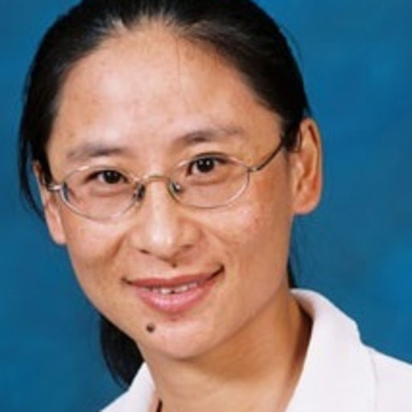
Dr. Ping Zhang is a Senior Research Fellow and currently leading the Bioinformatics Group at Menzies Health Institute Queensland (MHIQ), Griffith University Australia.
Prior to joining to Griffith in May 2015 she worked at Bond University, The University of Queensland and CSIRO (Commonwealth Scientific and Industrial Research Organization) as an Assistant Professor and Research Scientist. Her research interests include pattern recognition, applying machine learning and statistical techniques for medical decision making and biomarkers discovery. She developed computational modelling techniques and applied them to various health related research, such as diagnosis of cancers, influenza, cardiovascular diseases and diabetes, prediction of progression of Alzheimer’s, vaccine target identification and vaccine scheduling optimization etc. Recently, she worked on the projects that aim to discover how the changes in trace elements correlate with diseases. One of the projects is to explore the elemental profiles and the pattern change in women during pregnancy. It aims to develop elemental signatures to help diagnose and treat complications of pregnancy.

